Setting Up Podman & Podman Desktop

To install podman in a windows machine, you need to have Windows Subsystem for Linux and Virtual Machine turned on in your windows machine. To do that follow the below steps.
- Go to start.
- Search for “Turn Windows features on or off”.
- Check the “Virtual Machine” and “Windows Subsystem for Linux” checkbox.
After checking and clicking ok, it might ask to reboot your computer.
Now after the restart, to install podman go to below link:
https://github.com/containers/podman/releases
and download the latest setup exe.
Install the downloaded exe and follow the instructions in the setup if any.
After the installation is complete if it asks for restart, restart your system.
To check if you have podman installed in your system. Execute the below command in windows powershell.
“podman --version”

After this you can execute these commands to setup your podman environment.
- Open the terminal.
- Execute “podman machine init” to create your first machine.
- The init command will install a minimal installation of Fedora, customizing it to run Podman. After the init process is done, it could take few minutes.
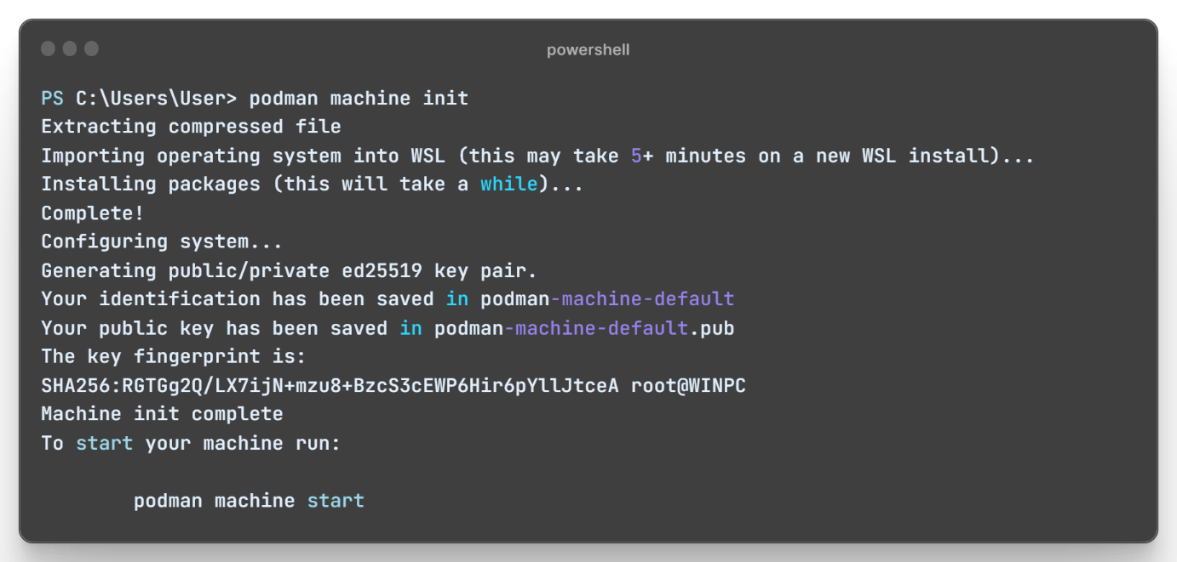

- You can execute “podman machine start” to start your machine.
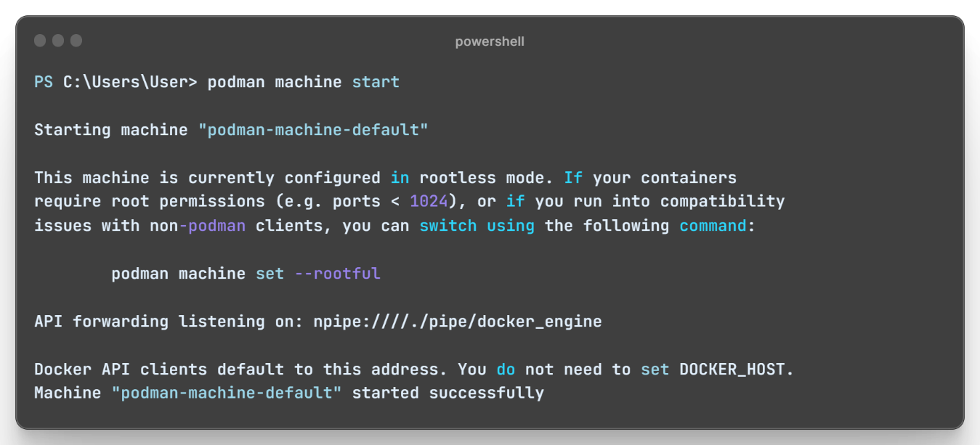
- Once your podman machine is successfully started, you can now build and run your podman images.

Now to download “Podman Desktop” you can go to the below link:
https://podman.io/
Click on download dropdown and select “Podman Desktop for Windows”, it will download the exe file.
Install the downloaded exe and follow the instructions in the setup if any.
After all this you can open your podman desktop application.
Setup wsl-vpnkit
Our spring application containers need to connect to our oracle database, but the wsl has its own network environment and it does not have the same localhost as your windows machine. So, to solve the problem for connecting the oracle database with our spring application container while using the vpn, we use this vpnkit.
NOTE: - This kit is only required for wsl only, we won’t be needing this kit in a linux based system.

To install the wsl-vpnkit you first need to download the tar.gz file.
Go to this link https://github.com/sakai135/wsl-vpnkit/releases/tag/v0.4.1
and download the “wsl-vpnkit.tar.gz”.

After downloading open the terminal and execute this command.
“wsl --import wsl-vpnkit $env:USERPROFILE\wsl-vpnkit "<Location of your wsl-vpnkit.tar.gz >” --version 2”
NOTE: - Make sure to provide the location of where you downloaded wsl-vpnkit.tar.gz.
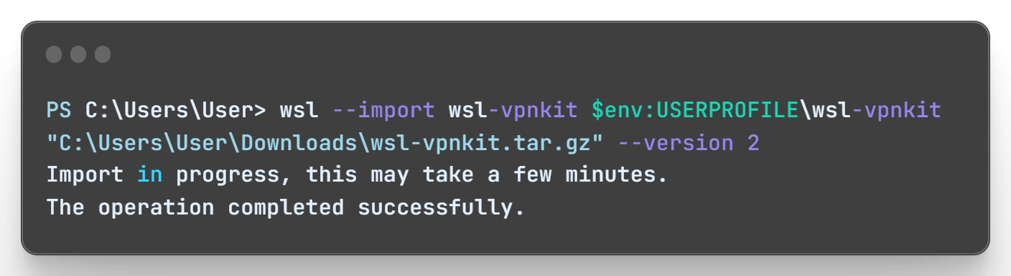
Now to start the wsl-vpnkit execute the below command.
“wsl.exe -d wsl-vpnkit --cd /app wsl-vpnkit”
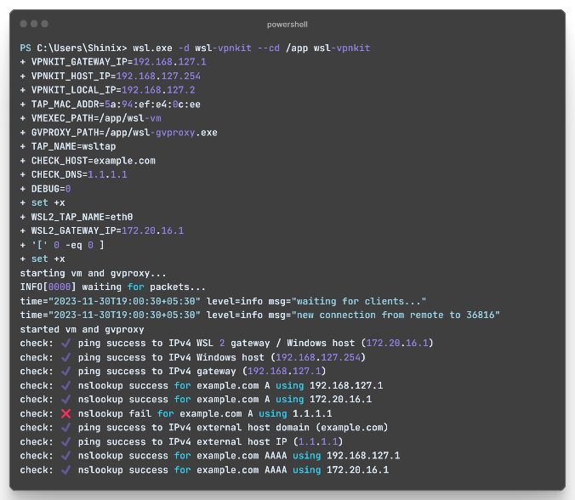
Now open a separate terminal and type “wsl” and hit enter.
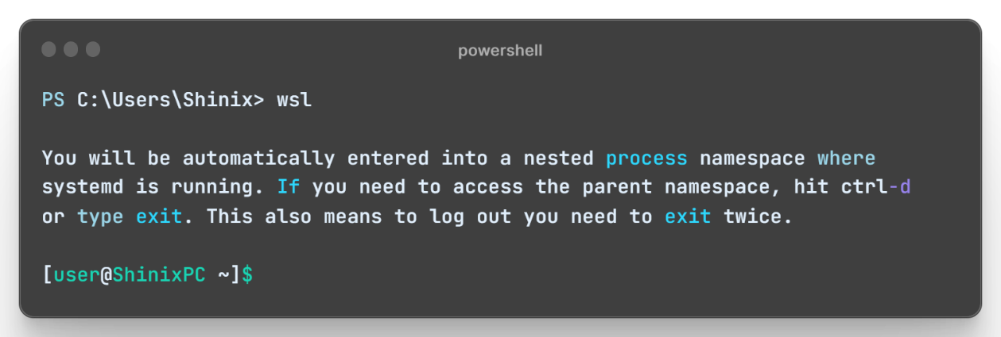
Also make sure your you are connected to your oracle network via your cisco vpn.
Now you can run this command to check if your able to ping your database or not.
“sudo ping -c 2 <your database Ip address”
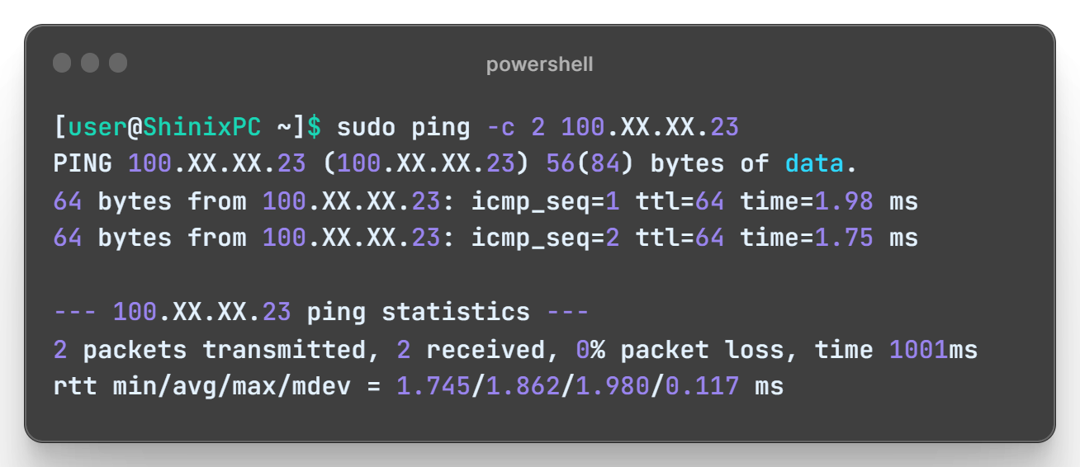
If it prints out “2 packets transmitted, 2 received, 0% packet loss, time 1002ms”
that means you were able to connect to your database successfully.

NOTE: - Whenever connecting your springboot container with database make sure you start wsl-vpnkit distro and keep the terminal open in which its running.

